**CMPE 272 - Ansible**

* Command to check ansible version

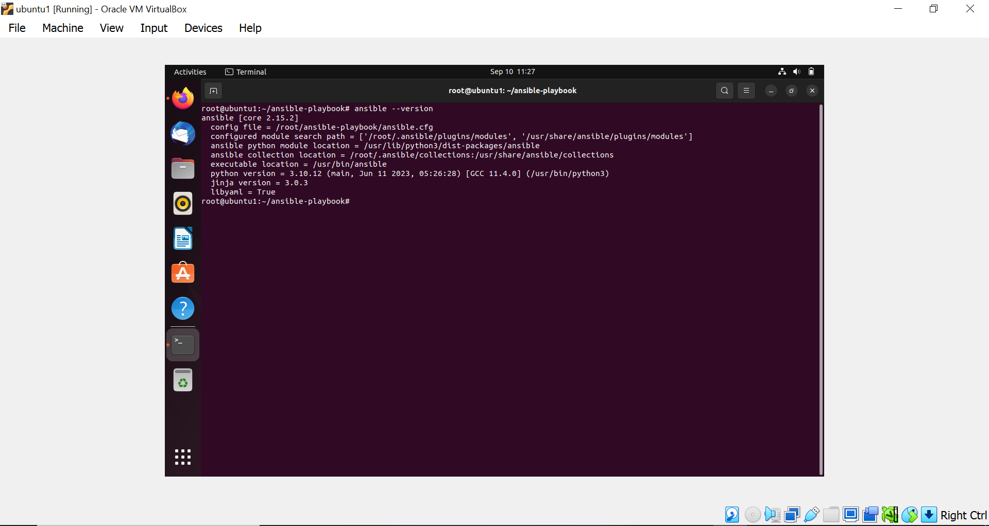

* All the files in the ansible-playbook folder

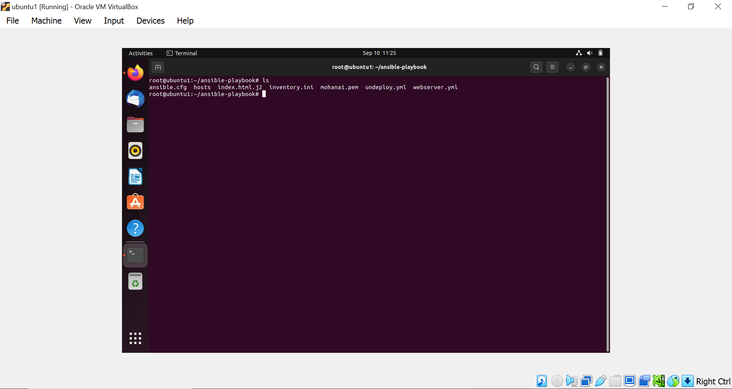

* RSA Private Key of the host(mohana1.pem)

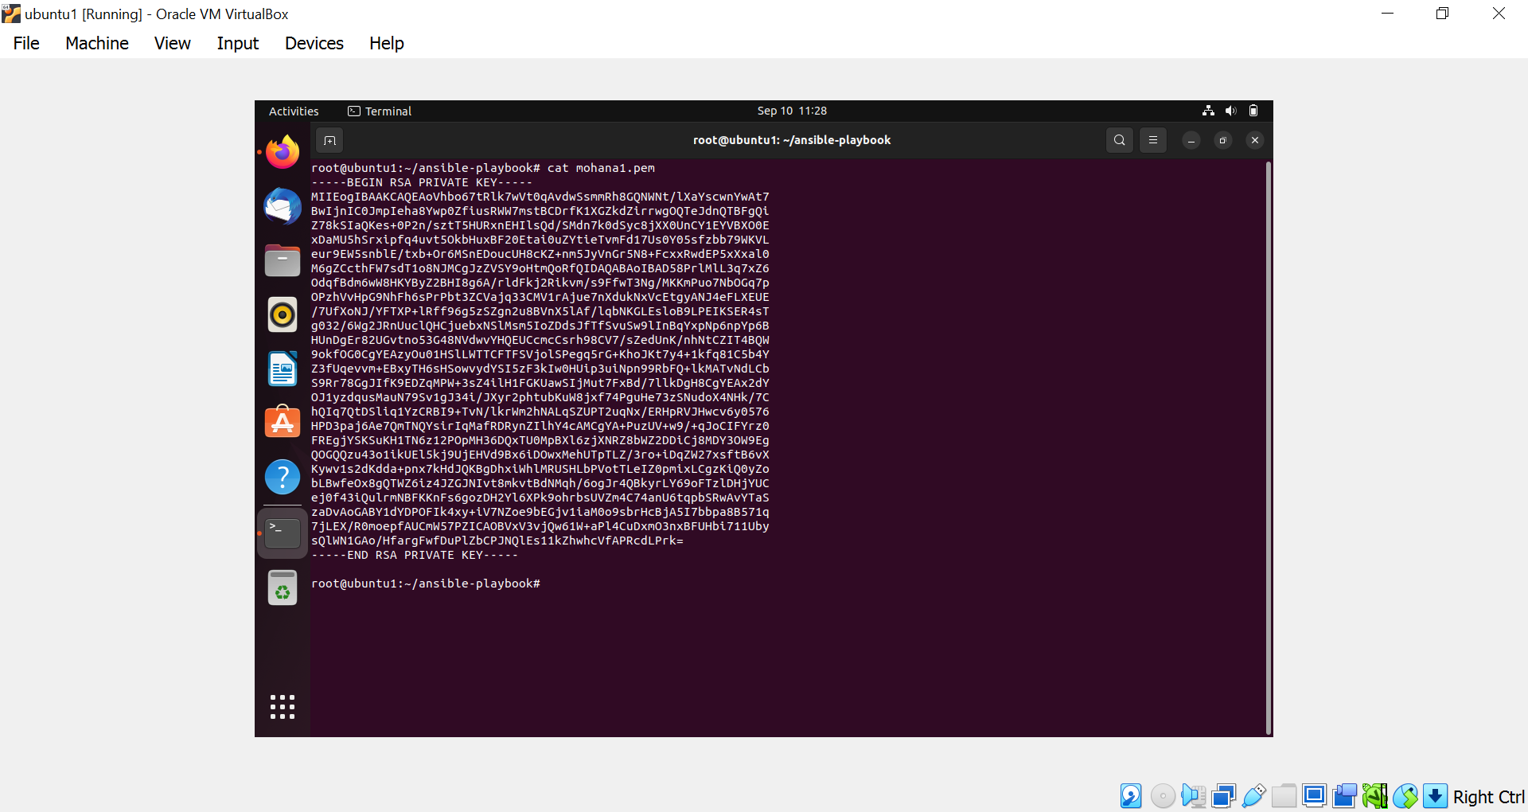

* Ansible config file to identify the private key(mohana1.pem)

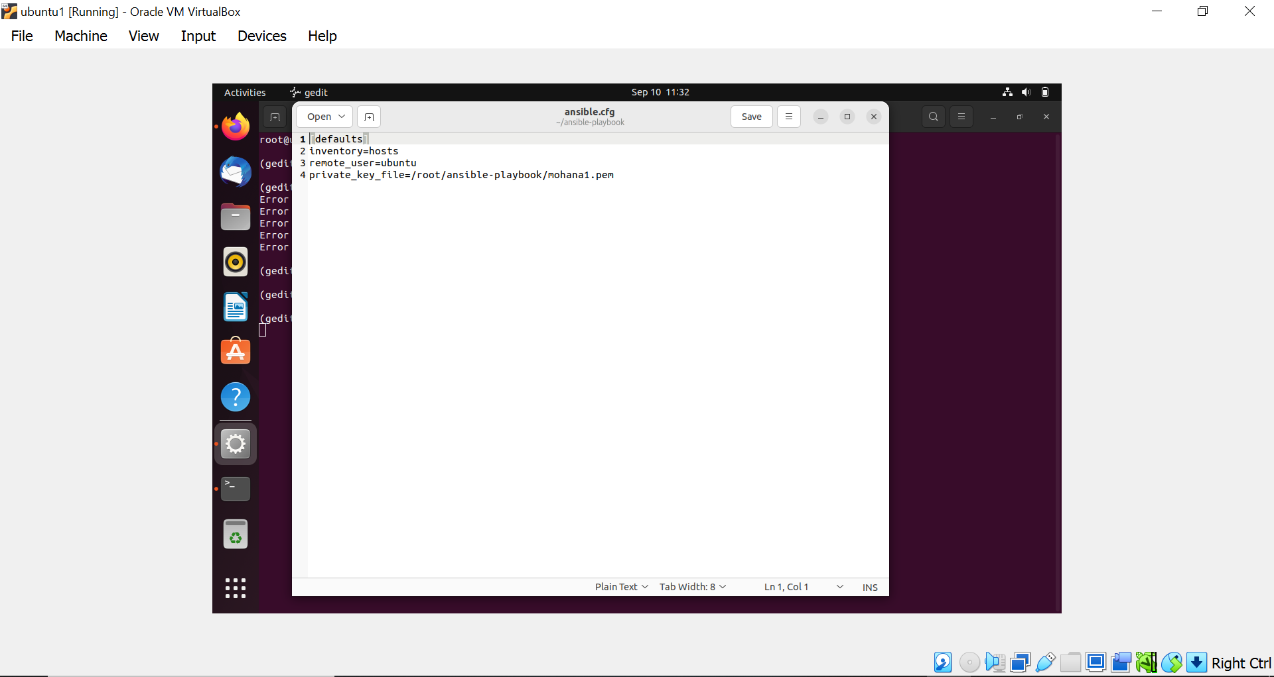

* Inventory.ini file which contains public IP of both the ec2 instances.

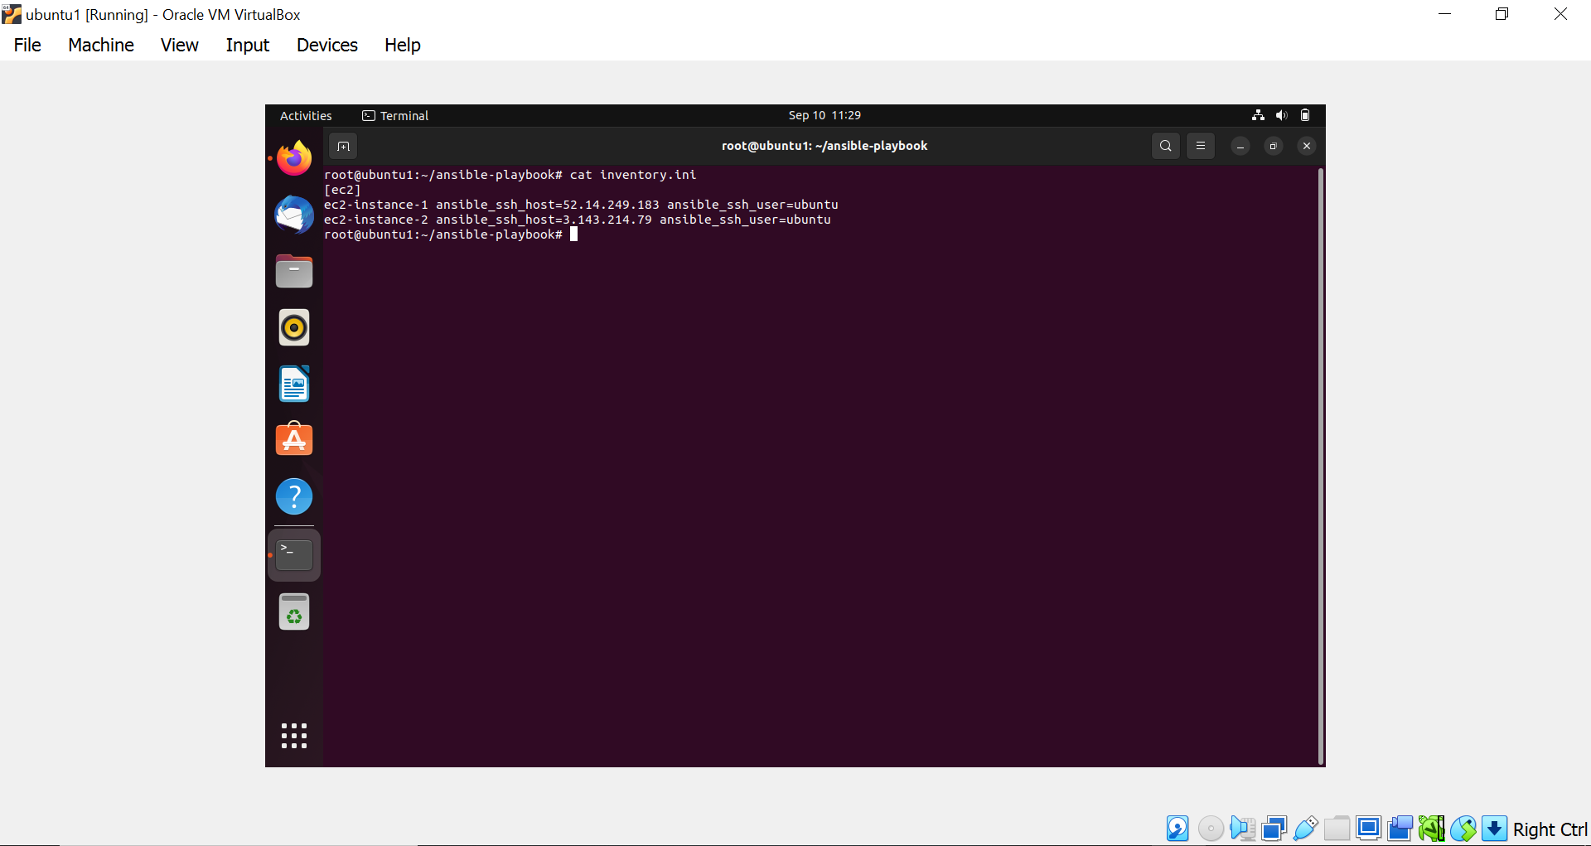

* Command to check if server is up and running.

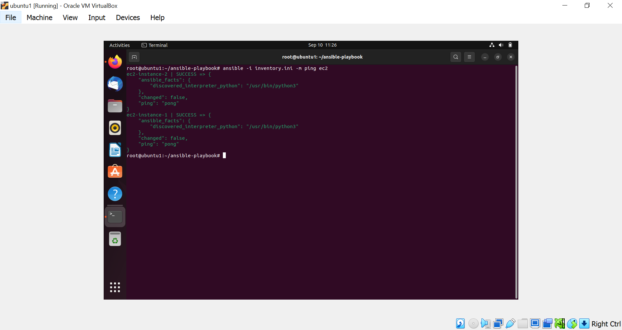

* Servers on Ec2 instance.

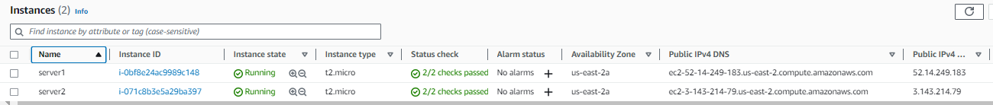

* ***Deployment script***

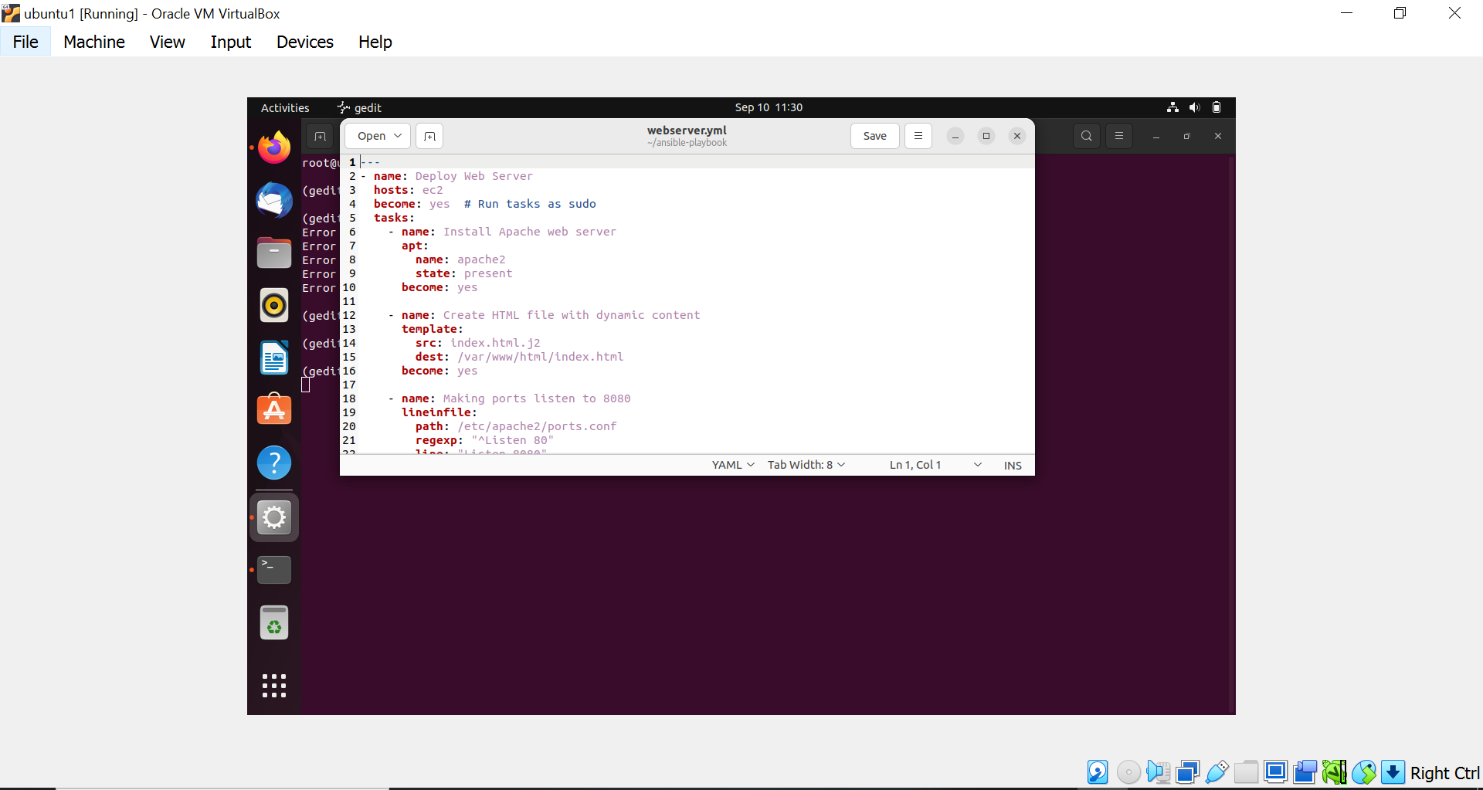

* Command to deploy the webpage on to the servers using playbook

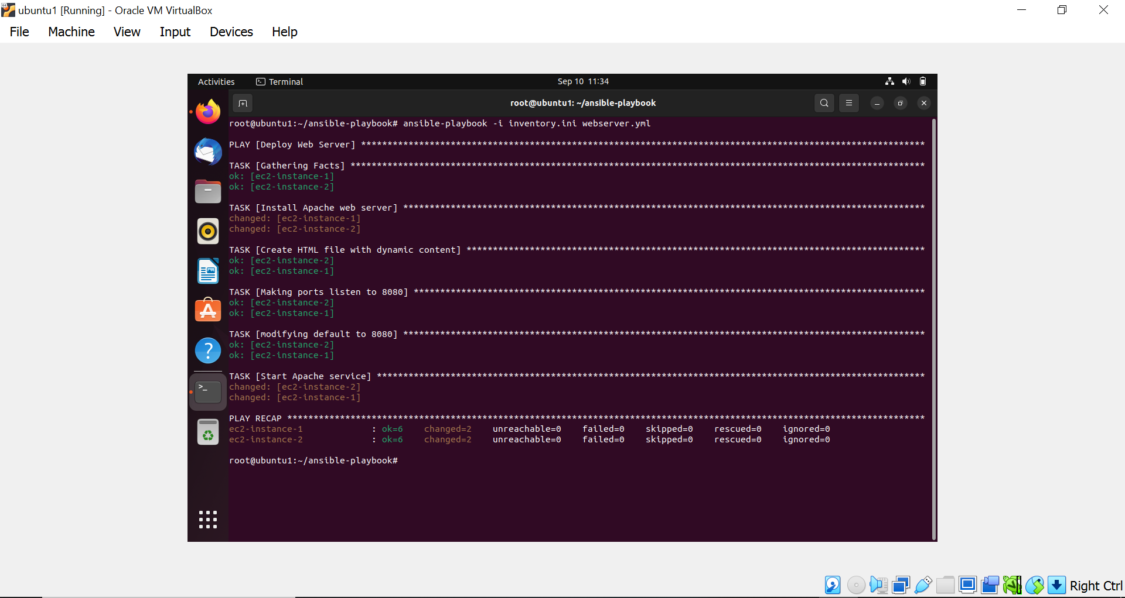

* Output of ec2 instance 1

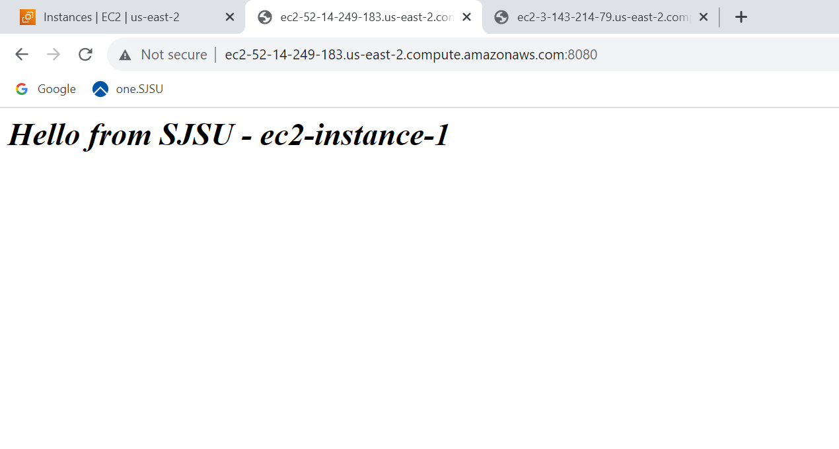

* Output of ec2 instance 2

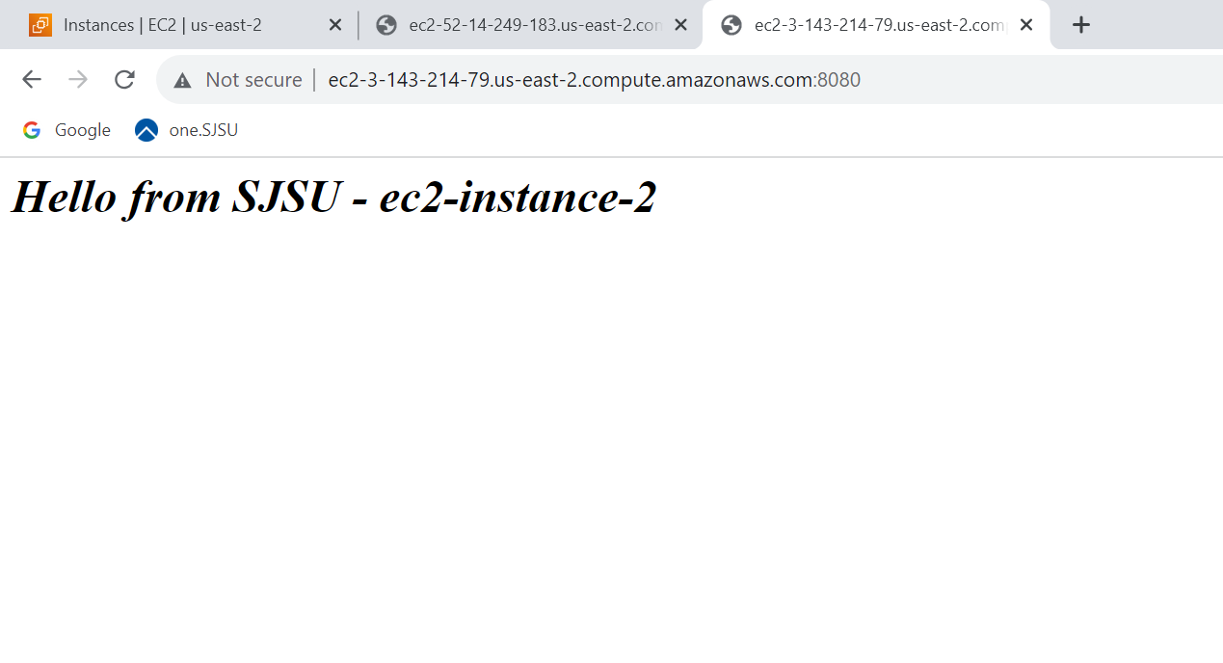

* ***Un-deployment Script***

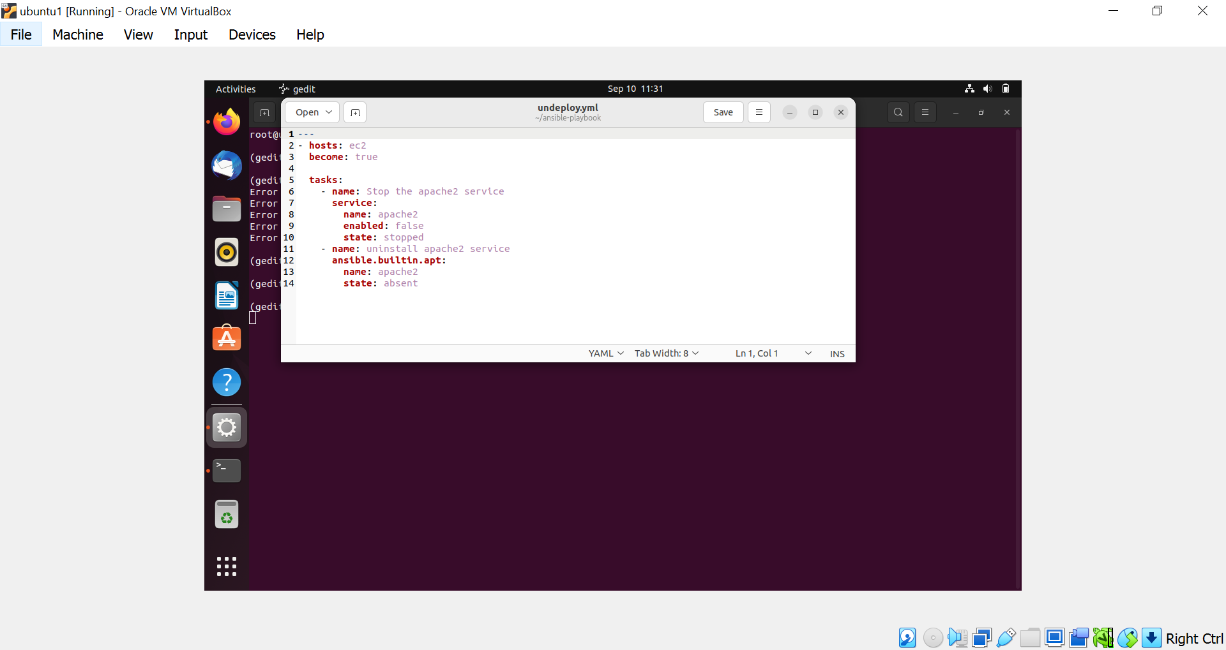

* Command to undeploy the webpages from ec2 instances using playbook.

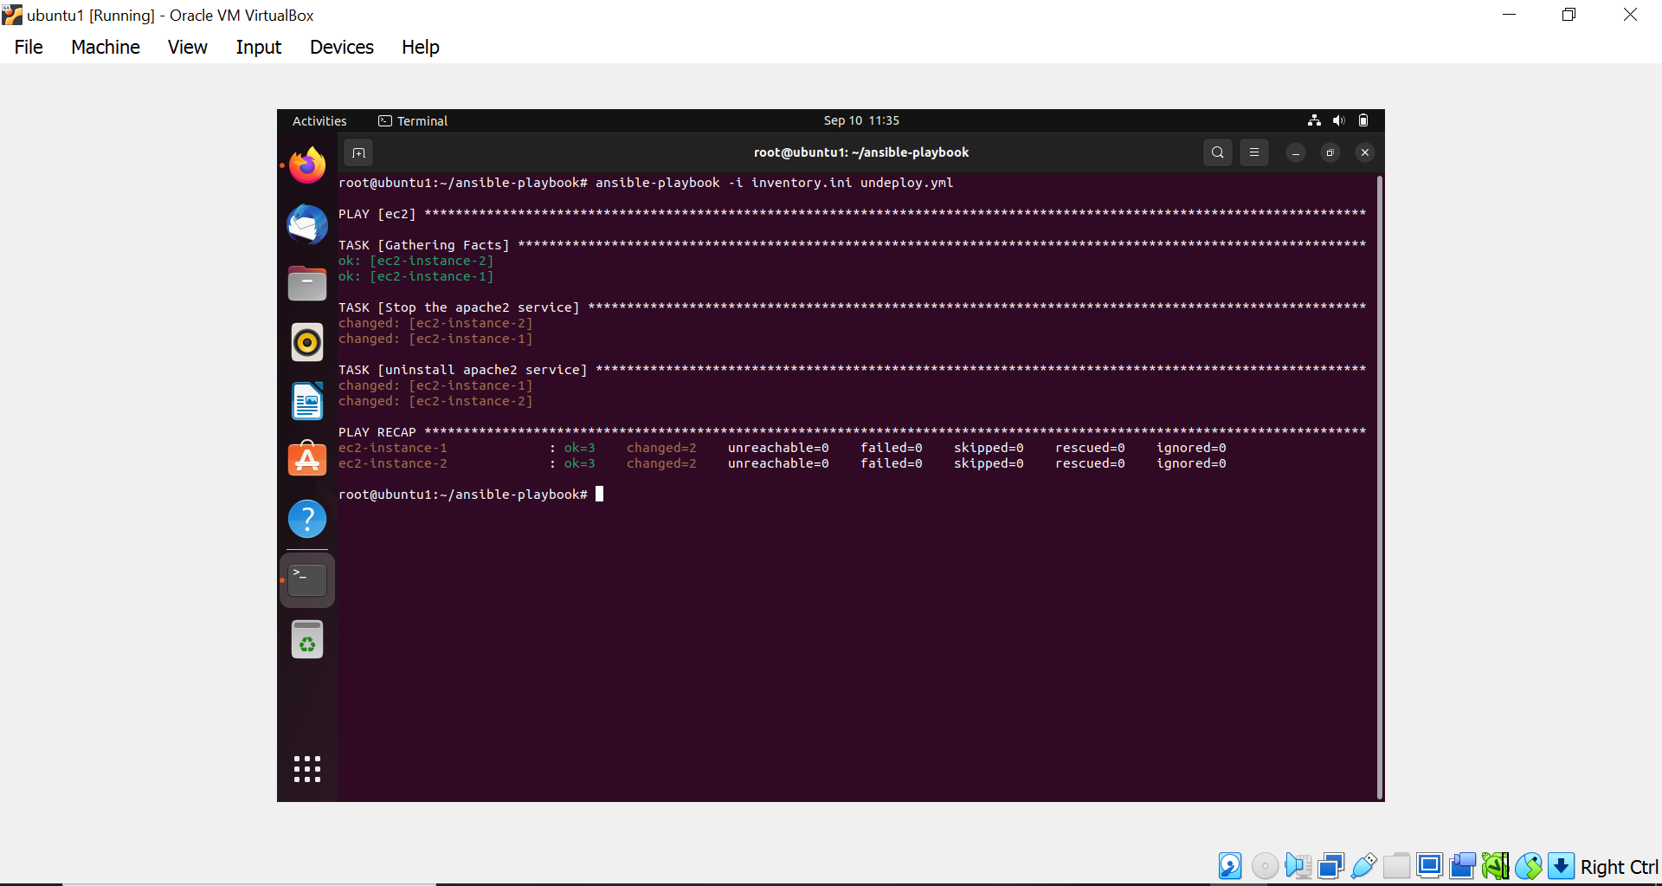

* Output after undeploying ec2 instance 1.

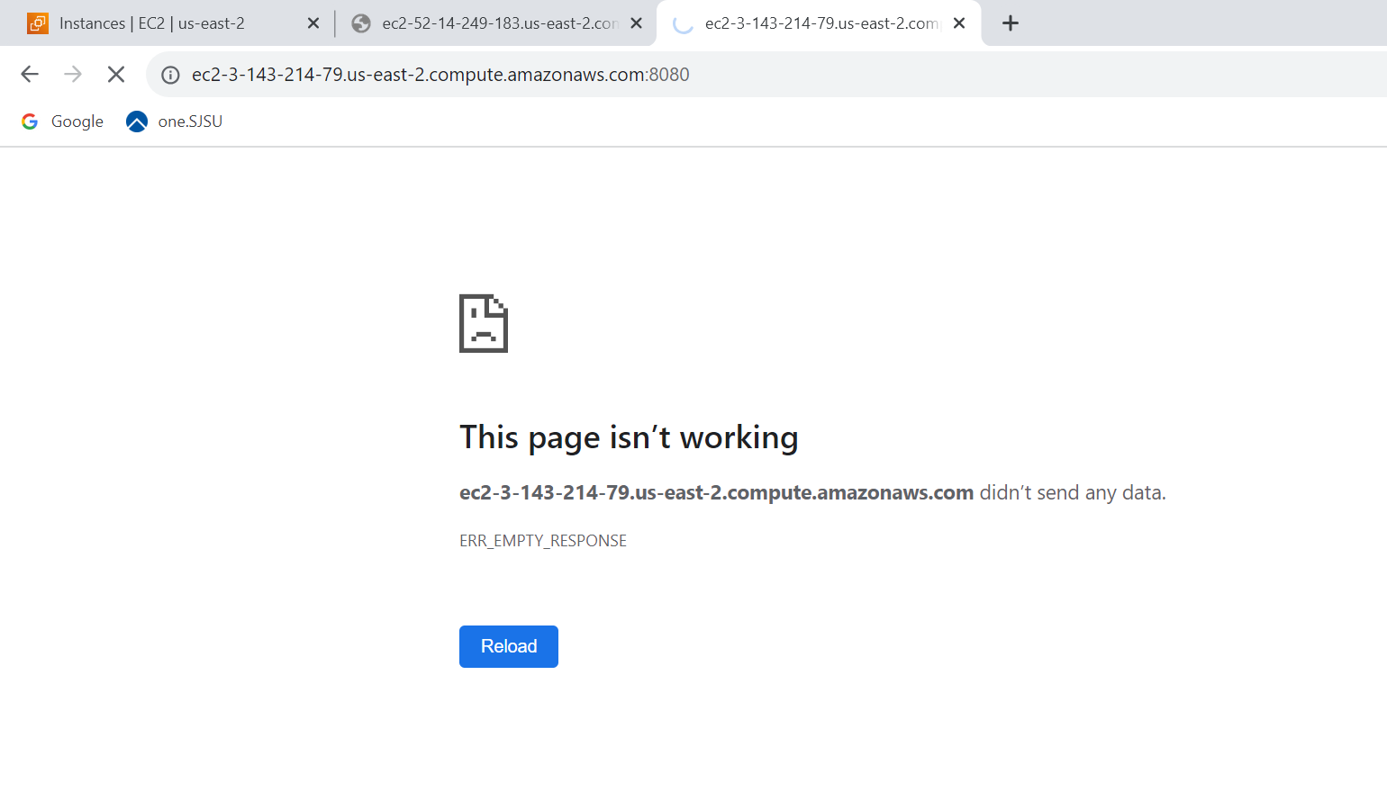

* Output after undeploying ec2 instance 2.

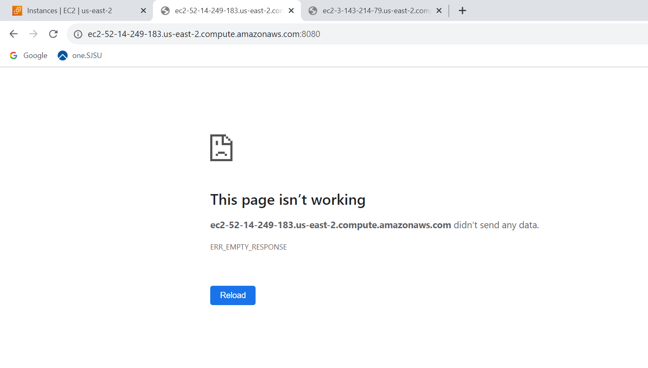

REFERENCES:  
<https://docs.ansible.com/>